Oscar Cortez
ITAI-4370: AI 5/6G Communications & ORAN Networks
Conceptual Communication System Diagram and Signal Flow Analysis
Instructor: Tawanda Chiyangwa
June 6, 2026

Part 1: Conceptual Diagram

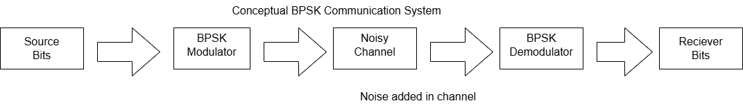
This diagram shows a simple BPSK digital communication system. The source generates binary bits, which are sent to the BPSK modulator. The modulator converts the bits into signal values that can travel through the channel. Noise is added in the channel to represent real-world interference. The BPSK demodulator then interprets the received signal and converts it back into receiver bits.
Part 2: Signal Flow Analysis in Python
Python Code:
import numpy as np
import matplotlib.pyplot as plt

# Source bits
bits = np.array([1, 0, 1, 1, 0, 0, 1, 0])

# BPSK modulation: 1 = +1, 0 = -1
bpsk_signal = 2 * bits - 1

# Add random noise to simulate the channel
noise = np.random.normal(0, 0.4, len(bpsk_signal))
received_signal = bpsk_signal + noise

# Demodulation: positive = 1, negative = 0
recovered_bits = (received_signal > 0).astype(int)

# Plot source bits
plt.figure(figsize=(10, 4))
plt.stem(bits)
plt.title("Source Bits")
plt.xlabel("Bit Index")
plt.ylabel("Bit Value")
plt.grid(True)
plt.show()

# Plot BPSK modulated signal
plt.figure(figsize=(10, 4))
plt.stem(bpsk_signal)
plt.title("BPSK Modulated Signal")
plt.xlabel("Bit Index")
plt.ylabel("Amplitude")
plt.grid(True)
plt.show()

# Plot noisy received signal
plt.figure(figsize=(10, 4))
plt.stem(received_signal)
plt.title("Received Signal After Noisy Channel")
plt.xlabel("Bit Index")
plt.ylabel("Amplitude")
plt.grid(True)
plt.show()

# Plot recovered bits
plt.figure(figsize=(10, 4))
plt.stem(recovered_bits)
plt.title("Recovered Receiver Bits")
plt.xlabel("Bit Index")
plt.ylabel("Bit Value")
plt.grid(True)
plt.show()

print("Source bits: ", bits)
print("Recovered bits:", recovered_bits)

Matplotlib Output Plots:
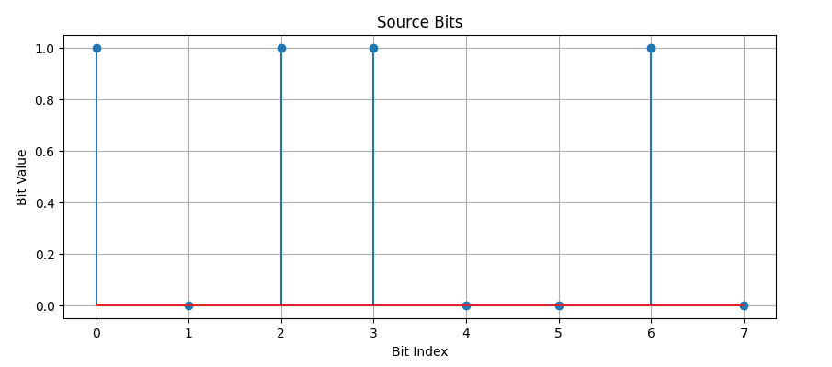
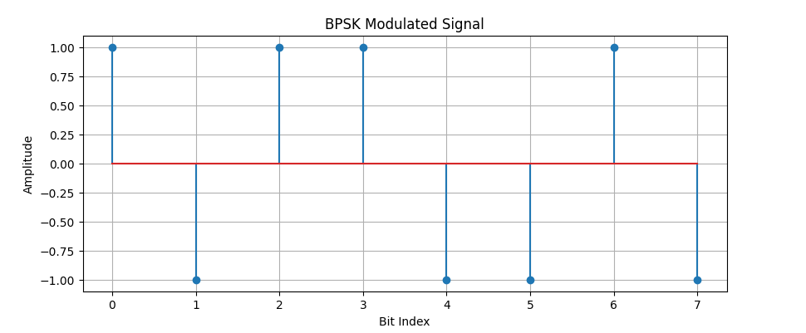
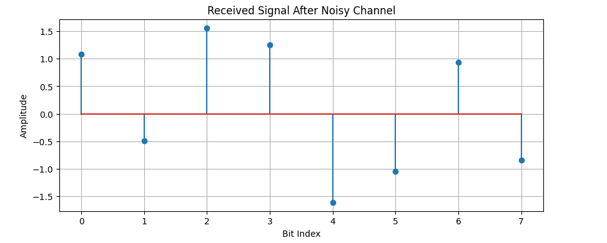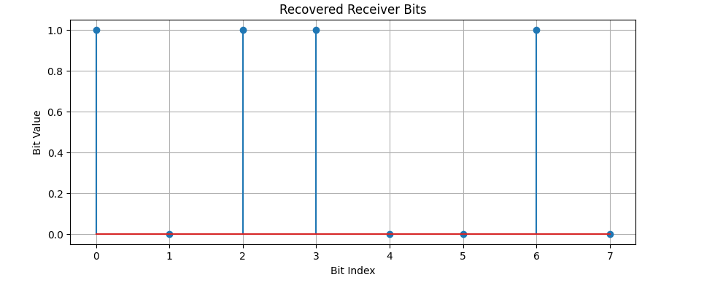
The plots show how the original binary bits move through the communication system. The BPSK modulated signal converts each bit into an amplitude value, where 1 becomes +1 and 0 becomes -1. The noisy channel plot shows how random noise changes the signal during transmission. The recovered receiver bits plot shows that the receiver can still recover the original bit pattern by using a zero threshold decision.

